2022-2023 EĞİTİM ÖĞRETİM YILI ............... ORTAOKULU 5. SINIFLAR SEÇMELİ İNGİLİZCE DERSİ ÜNİTELENDİRİLMİŞ YILLIK DERS PLANI
MONTH | DAYS | HOURS | THEME | Functions and Useful Language | Language Skills and Learning Outcomes | Materials | Evaluation
SEPTEMBER | 12-16 | 2 | 1- Hello! | Greeting and meeting people  Expressing likes and dislikes  Making simple inquiries  https://www.ingilizceciyiz.com/ | *Students will be able to understand simple personal information.  *Students will be able to introduce themselves and meet other people.  *Students will be able to exchange simple personal information.  *Students will be able to read Picture stories, conversations and cartoons about personal information.  *Students will be able to read their timetable for their lessons. | Student’s book  Interactive board  Teacher’s resources  Worksheet  Educational CD  Hand-made puppets  Real objects  Posters  Visual aids
 | 19-23 | 2
 | 26-30 | 2
OCTOBER | 03 Oct – 07 Oct | 2
 | 10-14 | 2 | 2- My town | Talking about locations of things and people  Asking for and giving directions (Making simple inquiries) | *Students will be able to understand simple directions to get from one place to another.  *Students will be able to recognize the use of rising intonation to ask for clarification.  *Students will be able to talk about the locations of things and people in simple conversations.  * Students will be able to give directions in a simple way.  *Students will be able to understand information about important places | Student’s book  Interactive board  Teacher’s resources  Worksheet  Educational CD  Hand-made puppets  Real objects  Posters  Visual aids
 | 17-21 | 2
 | 24-28 | 2
2022-2023 EĞİTİM ÖĞRETİM YILI ............... ORTAOKULU 5. SINIFLAR SEÇMELİ İNGİLİZCE DERSİ ÜNİTELENDİRİLMİŞ YILLIK DERS PLANI
MONTH | DAYS | HOURS | THEME | Functions and Useful Language | Language Skills and Learning Outcomes | Materials | Evaluation
OCTOBER | 31-04 November | 2 | 3- Games and Hobbies | Describing what people do regularly  Expressing ability and inability  Expressing likes and dislikes | *Students will be able to understand simple, oral texts about hobbies, likes/dislikes  and abilities.  *Students will be able to talk about hobbies, likes/dislikes and abilities in a simple way.  *Students will be able to give information about likes/dislikes, abilities and hobbies of others in a simple way.  *Students will be able to follow a simple story with visual aids. | Student’s book  Interactive board  Teacher’s resources  Worksheet  Educational CD  Hand-made puppets  Real objects  Posters  Visual aids | 1ST WRITTEN EXAM
NOVEMBER | 07-11 | 2
 | 14-18 NOVEMBER MID-TERM HOLIDAY
 | 21-25 | 2 | 4- My Daily Routine | Describing what people do regularly (Making simple inquiries)  Telling the time  Naming numbers | *Students will be able to understand specific information in short, oral texts about daily routines.  *Students will be able to understand the time.  *Students will be able to talk about daily routines.  *Students will be able to use simple utterances to talk about daily routines of friends and family members.  *Students will be able to tell the time and numbers from 1 to 100.  *Students will be able to understand short and simple written texts about daily routines. | Student’s book  Student’s workbook  Interactive board  Teacher’s resources  Worksheet  Educational CD  Hand-made puppets  Real objects  Posters  Visual aids
DECEMBER | 28-02 DEC | 2
 | 05-09 | 2
 | 12-16 | 2
2022-2023 EĞİTİM ÖĞRETİM YILI ............... ORTAOKULU 5. SINIFLAR SEÇMELİ İNGİLİZCE DERSİ ÜNİTELENDİRİLMİŞ YILLIK DERS PLANI
MONTH | DAYS | HOURS | THEME | Functions and Useful Language | Language Skills and Learning Outcomes | Materials | Evaluation
DECEMBER | 19-23 | 2 | 5- Health | Expressing illnesses, needs and feelings  Making simple suggestions | *Students will be able to identify common illnesses and understand some of the suggestions made.  *Students will be able to understand simple suggestions concerning illnesses.  *Students will be able to name the common illnesses in a simple way.  *Students will be able to express basic needs and feelings about illnesses.  *Students will be able to understand short and simple texts about illnesses, needs and feelings. | Student’s book  Interactive board  Teacher’s resources  Worksheet  Educational CD  Hand-made puppets  Real objects  Posters  Visual aids | 2ND WRITTEN EXAM
 | 26-30 | 2
JANUARY | 02-06 | 2
 | 09-13 | 2
 | 16-20 | 2 | 6- Movies | Describing characters/people  Expressing likes and dislikes  Making simple inquiries  Stating personal opinions  Telling the time  https://www.ingilizceciyiz.com/ | *Students will be able to follow slow and carefully articulated speech describing movie characters and movie types.  *Students will be able to talk about people’s likes and dislikes concerning movies and movie characters.  *Students will be able to use simple utterances to state personal opinions about movies and movie characters.  *Students will be able to state the time of an event.  *Students will be able to understand phrases and simple sentences on posters and advertisements about movies and movie characters. | Student’s book  Interactive board  Teacher’s resources  Worksheet  Educational CD  Hand-made puppets  Real objects  Posters  Visual aids
23 JAN
03 FEB SEMESTER HOLIDAY
FEBRUARY | 06-10 | 2
 | 13-17 | 2
2022-2023 EĞİTİM ÖĞRETİM YILI ............... ORTAOKULU 5. SINIFLAR SEÇMELİ İNGİLİZCE DERSİ ÜNİTELENDİRİLMİŞ YILLIK DERS PLANI
MONTH | DAYS | HOURS | THEME | Functions and Useful Language | Language Skills and Learning Outcomes | Materials | Evaluation
FEBRUARY | 20-24 | 2 | 7- Party Time | Asking for permission  Expressing and responding to thanks  Greeting and meeting people  Expressing obligation  Telling the days and dates | *Students will be able to understand simple requests for permission and their responses.  *Students will be able to ask for permission and give response in a simple way.  *Students will be able to use basic greeting and leave-taking expressions.  *Students will be able to use utterances to express obligation.  *Students will be able to state the date of an event.  *Students will be able to express and respond to thanks.  *Students will be able to understand short texts with visual aids, such as cartoons, posters and birthday cards. | Student’s book  Interactive board  Teacher’s resources  Worksheet  Educational CD  Hand-made puppets  Real objects  Posters  Visual aids
MARCH | 27-03 | 2
 | 06-10 | 2
 | 13-17 | 2 | 8- Fitness | Making simple inquiries  Asking for clarification | *. Students will be able to understand simple oral texts about sports activities.  *Students will be able to understand suggestions made for a limited number of activities.  *Students will be able to make suggestions for a limited number of activities. | Student’s book  Interactive board  Teacher’s resources  Worksheet  Educational CD  Hand-made puppets  Real objects  Posters  Visual aids | 1ST WRITTEN EXAM
 | 20-24 | 2
 | 27-31 | 2 |  | Making/accepting/refusing simple suggestions | *Students will be able to accept or refuse suggestions in a simple way.  *Students will be able to give simple personal information.  *Students will be able to ask for clarification by asking the speaker to repeat what has been said.
APRIL | 03-07 | 2
 | 10-14 | 2
17-20 APRIL
MID-TERM HOLIDAY
2022-2023 EĞİTİM ÖĞRETİM YILI ............... ORTAOKULU 5. SINIFLAR SEÇMELİ İNGİLİZCE DERSİ ÜNİTELENDİRİLMİŞ YILLIK DERS PLANI
MONTH | DAYS | HOURS | THEME | Functions and Useful Language | Language Skills and Learning Outcomes | Materials | Evaluation
APRIL | 24-28 | 2 | 9- The Animal Shelter | Asking for permission (Making simple inquiries)  Describing what people/animals are doing now  https://www.ingilizceciyiz.com/ | *Students will be able to understand descriptions of what people/animals are doing at the moment.  *Students will be able to talk about what people/animals are doing at the moment.  *Students will be able to ask for permission.  *Students will be able to understand short and simple texts about what people/animals are doing at the moment. | Student’s book  Interactive board  Teacher’s resources  Worksheet  Educational CD  Hand-made puppets  Real objects  Posters  Visual aids
 | 01-05 | 2
MAY | 08-12 | 2
 | 15-19 | 2
 | 22-26 | 2 | 10- Festivals | Describing general events and repeated actions  (Making simple inquiries)  Naming numbers | *Students will be able to understand simple texts about festivals around the world.  *Students will be able to describe the events in a festival in a simple way.  *Students will be able to understand visually supported short texts about festivals  around the world. | Student’s book  Interactive board  Teacher’s resources  Worksheet  Educational CD  Hand-made puppets  Real objects  Posters  Visual aids | 2ND WRITTEN EXAM
 | 29-02 | 2
JUNE | 05-09 | 2
 | 12-16 | 2
https://www.ingilizceciyiz.com/
UYGUNDUR
Okan GÜLTEKİN 09/09/2022
İngilizce Öğretmeni Sadece sosyal medyada yayınladığımız ücretsiz İngilizce Öğretmenlerine Özel Yazılı Soruları
ve ihtiyacınız olan tüm evraklar için sosyal medya hesaplarımızdan bizi takip ediniz! OKUL MÜDÜRÜ
https://www.facebook.com/groups/ingilizceciyiz https://www.instagram.com/ingilizceciyiz_com/ https://twitter.com/ingilizceciyiz1

Bu planı cep telefonunuzda kullanmak için aşağıdaki bağlantılardan mobil uygulamamızı indirin. Ücretsiz! (Bağlantı için Ctrl + Tıkla)

Bu plan ingilizceciyiz.com sitesinin izni ile osmankarakaya.net sitesinde paylaşılmaktadır.
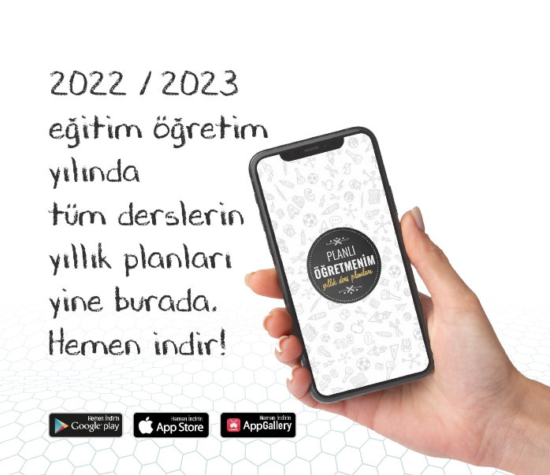 | 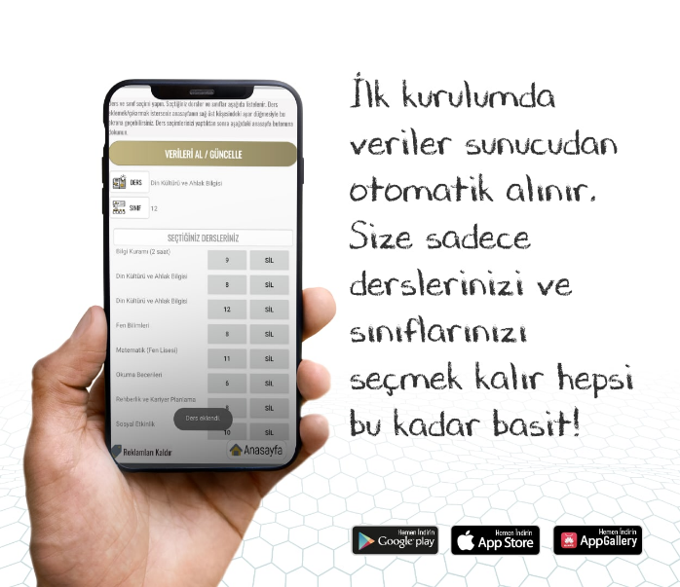 | 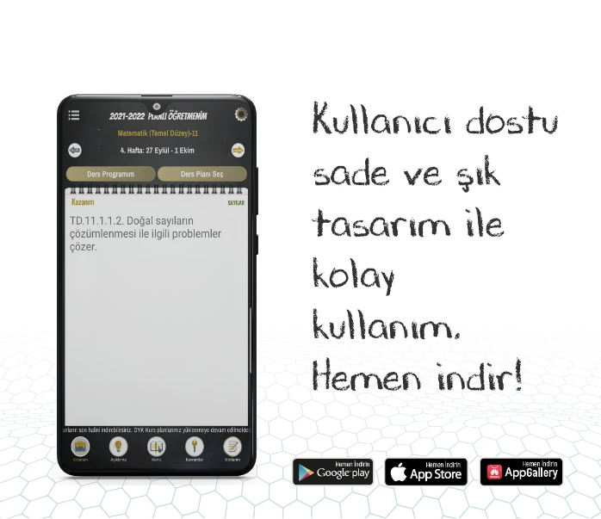
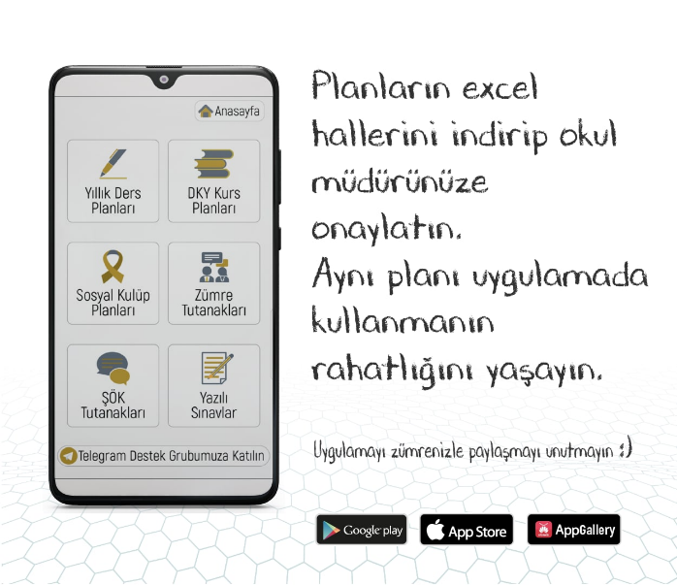 | 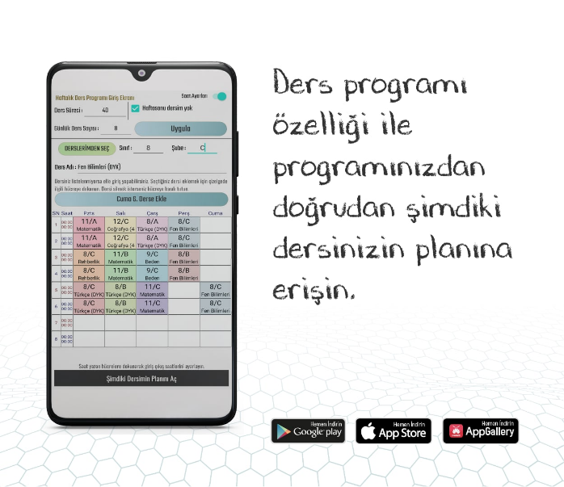 | 