2022-2023 EĞİTİM ÖĞRETİM YILI ............... ORTAOKULU 6. SINIFLAR SEÇMELİ İNGİLİZCE DERSİ ÜNİTELENDİRİLMİŞ YILLIK DERS PLANI
MONTH | DAYS | HOURS | THEME | Functions and Useful Language | Language Skills and Learning Outcomes | Materials | Evaluation
SEPTEMBER | 12-16 | 2 | 1- Life | Describing what people do regularly  Making simple inquiries  Telling the time, days and dates  https://www.ingilizceciyiz.com/ | • Students will be able to recognize phrases, words, and expressions related to actions people do regularly.  • Students will be able to ask what other people do regularly and respond to questions about the actions they do regularly.  • Students will be able to use a series of phrases and simple expressions to express their regular actions.  • Students will be able to tell the time and days.  • Students will be able to read short, simple texts such as personal narratives about what people do regularly. | Student’s book  Interactive board  Teacher’s resources  Worksheet  Educational CD  Hand-made puppets  Real objects  Posters  Visual aids
 | 19-23 | 2
 | 26-30 | 2
 | 03 Oct – 07 Oct | 2
OCTOBER | 10-14 | 2 | 2- Yummy Breakfast | Accepting and refusing  Describing what people do regularly  Expressing likes and dislikes | • Students will be able to identify the names of different food items when listening to a conversation.  • Students will be able to ask people about their food preferences at breakfast.  • Students will be able to express their opinions about the food they like and don’t like.  • Students will be able to understand short, simple, written texts about predictable, everyday matters such as food and personal opinions.  • Students will be able to read the label of a food product.  • Students will become familiar with breakfast habits of different cultures. | Student’s book  Interactive board  Teacher’s resources  Worksheet  Educational CD  Hand-made puppets  Real objects  Posters  Visual aids
 | 17-21 | 2
 | 24-28 | 2
2022-2023 EĞİTİM ÖĞRETİM YILI ............... ORTAOKULU 6. SINIFLAR SEÇMELİ İNGİLİZCE DERSİ ÜNİTELENDİRİLMİŞ YILLIK DERS PLANI
MONTH | DAYS | HOURS | THEME | Functions and Useful Language | Language Skills and Learning Outcomes | Materials | Evaluation
OCTOBER | 31-04 November | 2 | 3- Downtown | Describing places  Describing what people are doing now  Making comparisons  Making simple inquiries | • Students will be able to identify expressions and phrases related to present events.  • Students will be able to pick up the expressions used while comparing things in a dialogue.  • Students will be able to ask people questions about what they are doing at the moment.  • Students will be able to ask people to compare things.  • Students will be able to describe people doing different actions.  • Students will be able to make comparisons between two things.  • Students will be able to read visually supported, short, simple, written statements. | Student’s book  Interactive board  Teacher’s resources  Worksheet  Educational CD  Hand-made puppets  Real objects  Posters  Visual aids | 1ST WRITTEN EXAM
NOVEMBER | 07-11 | 2
 | 14-18 NOVEMBER MID-TERM HOLIDAY
 | 21-25 | 2 | 4- weather and Emotions | Describing the weather  Expressing feelings  Making simple inquiries  https://www.ingilizceciyiz.com/ | • Students will be able to pick up the essential information in short passages about weather conditions.  • Students will be able to ask people about the weather.  • Students will be able to talk about and answer simple questions, initiate and respond to simple statements about everyday matters (i.e., weather and emotions).  • Students will be able to understand short, simple written texts about predictable everyday matters such as emotions and weather.  • Students will be able to say when they don’t understand and ask for repetition. | Student’s book  Student’s workbook  Interactive board  Teacher’s resources  Worksheet  Educational CD  Hand-made puppets  Real objects  Posters  Visual aids
DECEMBER | 28-02 DEC | 2
 | 05-09 | 2
 | 12-16 | 2
2022-2023 EĞİTİM ÖĞRETİM YILI ............... ORTAOKULU 6. SINIFLAR SEÇMELİ İNGİLİZCE DERSİ ÜNİTELENDİRİLMİŞ YILLIK DERS PLANI
MONTH | DAYS | HOURS | THEME | Functions and Useful Language | Language Skills and Learning Outcomes | Materials | Evaluation
DECEMBER | 19-23 | 2 | 5- At the Fair | Describing places  Expressing feelings  Expressing likes and dislikes  Stating personal opinions | • Students will be able to recognize the words related to the expression of emotions/feelings.  • Students will be able to ask people and express their feelings and opinions about places and things.  • Students will be able to use a series of phrases and simple expressions to express their feelings personal opinions about places and things.  • Students will be able to read short information on a poster about a certain place.  • Students will be able to understand general meaning in simple texts related to the feelings and personal opinions about places and things. | Student’s book  Interactive board  Teacher’s resources  Worksheet  Educational CD  Hand-made puppets  Real objects  Posters  Visual aids | 2ND WRITTEN EXAM
 | 26-30 | 2
JANUARY | 02-06 | 2
 | 09-13 | 2
 | 16-20 | 2 | 6- Occupations | Talking about occupations  Asking personal questions  Telling the time, days and dates | • Students will be able to understand familiar words and simple phrases concerning people’s occupations in clear texts.  • Students will be able to understand the time, days and dates.  • Students will be able to talk about occupations.  • Students will be able to ask personal questions.  • Students will be able to state the dates.  • Students will be able to understand familiar words and simple sentences about occupations and the dates.  • Students will be able to produce a piece of writing about occupations and the dates. | Student’s book  Interactive board  Teacher’s resources  Worksheet  Educational CD  Hand-made puppets  Real objects  Posters  Visual aids
23 JAN
03 FEB SEMESTER HOLIDAY
FEBRUARY | 06-10 | 2
 | 13-17 | 2
2022-2023 EĞİTİM ÖĞRETİM YILI ............... ORTAOKULU 6. SINIFLAR SEÇMELİ İNGİLİZCE DERSİ ÜNİTELENDİRİLMİŞ YILLIK DERS PLANI
MONTH | DAYS | HOURS | THEME | Functions and Useful Language | Language Skills and Learning Outcomes | Materials | Evaluation
FEBRUARY | 20-24 | 2 | 7- Holidays | Talking about past events  https://www.ingilizceciyiz.com/ | • Students will be able to spot the activities about holidays in texts.  • Students will be able to talk about their holidays.  • Students will be able to describe past activities and personal experiences.  • Students will be able to understand short, simple sentences and expressions related to past activities.  • Students will be able to write short and simple pieces in various forms about holidays. | Student’s book  Interactive board  Teacher’s resources  Worksheet  Educational CD  Hand-made puppets  Real objects  Posters  Visual aids
MARCH | 27-03 | 2
 | 06-10 | 2
 | 13-17 | 2 |  | Talking about locations of things  Talking about past events  Making/accepting/refusing simple suggestions | • Students will be able to talk about the locations of people and things.  • Students will be able to describe the locations of people and things.  • Students will be able to describe past events and write with definite time.  • Students will be able to write about the locations of people and things.  *Students will be able to accept or refuse suggestions in a simple way.  *Students will be able to give simple personal information. | Student’s book  Interactive board  Teacher’s resources  Worksheet  Educational CD  Hand-made puppets  Real objects  Posters  Visual aids | 1ST WRITTEN EXAM
 | 20-24 | 2 | 8- Bookworms
 | 27-31 | 2
APRIL | 03-07 | 2
 | 10-14 | 2
17-20 APRIL
MID-TERM HOLIDAY
2022-2023 EĞİTİM ÖĞRETİM YILI ............... ORTAOKULU 6. SINIFLAR SEÇMELİ İNGİLİZCE DERSİ ÜNİTELENDİRİLMİŞ YILLIK DERS PLANI
MONTH | DAYS | HOURS | THEME | Functions and Useful Language | Language Skills and Learning Outcomes | Materials | Evaluation
APRIL | 24-28 | 2 | 9- Saving the Planet | Giving and responding to simple instructions  https://www.ingilizceciyiz.com/ | • Students will be able to identify appropriate behavior to save energy and to protect the environment.  • Students will be able to understand suggestions related to the protection of the environment in simple texts.  • Students will be able to give each other suggestions about the protection of the environment.  • Students will be able to talk to people about the protection of the environment.  • Students will be able to understand the texts about the protection of the environment.  • Students will be able to follow short, simple written instructions.  • Students will be able to write simple pieces about the protection of the environment. | Student’s book  Interactive board  Teacher’s resources  Worksheet  Educational CD  Hand-made puppets  Real objects  Posters  Visual aids
MAY | 01-05 | 2
 | 08-12 | 2
 | 15-19 | 2
 | 22-26 | 2 | 10- Democracy | Talking about stages of a procedure  Making simple inquiries  Talking about past events | • Students will be able to recognize some key features related to the concept of democracy.  • Students will be able to talk about the stages of classroom president polls.  • Students will be able to give short descriptions of past and present events.  • Students will be able to talk about the concept of democracy.  • Students will be able to recognize familiar words and simple phrases related to the concept of democracy..  • Students will be able to write simple pieces about concepts related to democracy. | Student’s book  Interactive board  Teacher’s resources  Worksheet  Educational CD  Hand-made puppets  Real objects  Posters  Visual aids | 2ND WRITTEN EXAM
 | 29-02 | 2
JUNE | 05-09 | 2
 | 12-16 | 2
https://www.ingilizceciyiz.com/
UYGUNDUR
Okan GÜLTEKİN 09/09/2022
İngilizce Öğretmeni Sadece sosyal medyada yayınladığımız ücretsiz İngilizce Öğretmenlerine Özel Yazılı Soruları
ve ihtiyacınız olan tüm evraklar için sosyal medya hesaplarımızdan bizi takip ediniz! OKUL MÜDÜRÜ
https://www.facebook.com/groups/ingilizceciyiz https://www.instagram.com/ingilizceciyiz_com/ https://twitter.com/ingilizceciyiz1

Bu planı cep telefonunuzda kullanmak için aşağıdaki bağlantılardan mobil uygulamamızı indirin. Ücretsiz! (Bağlantı için Ctrl + Tıkla)

Bu plan ingilizceciyiz.com sitesinin izni ile osmankarakaya.net sitesinde paylaşılmaktadır.
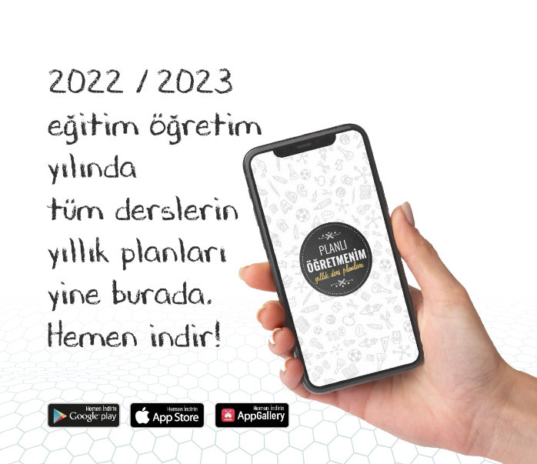 | 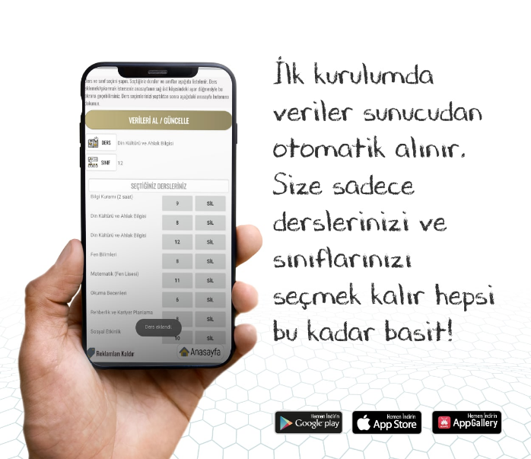 | 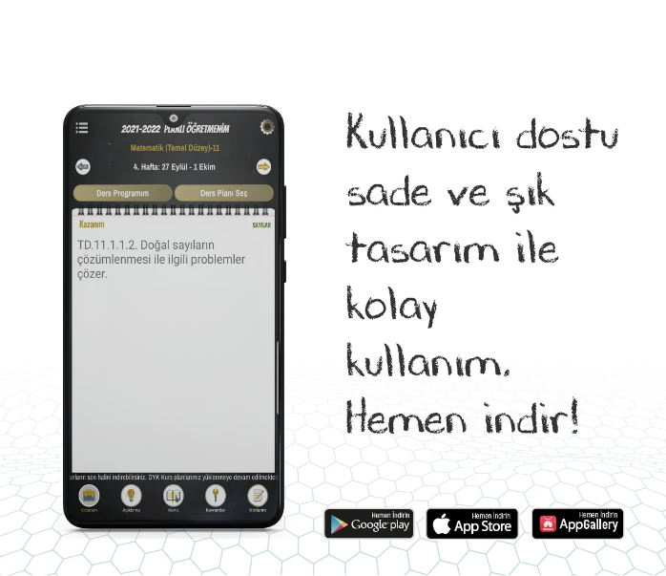
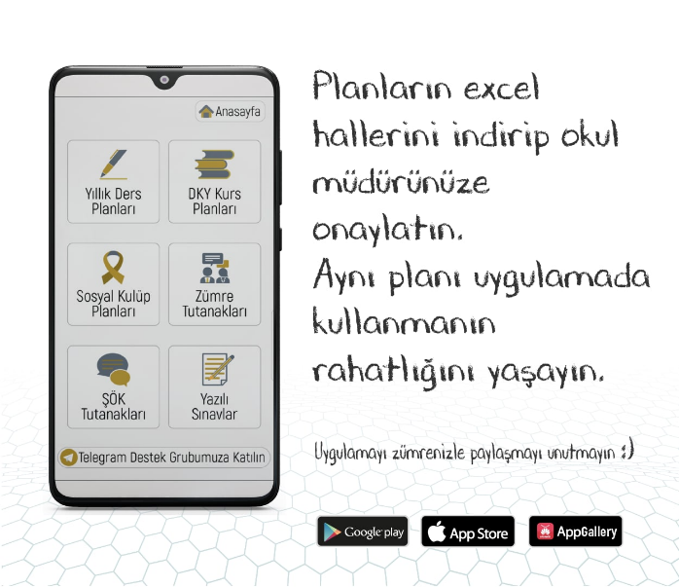 | 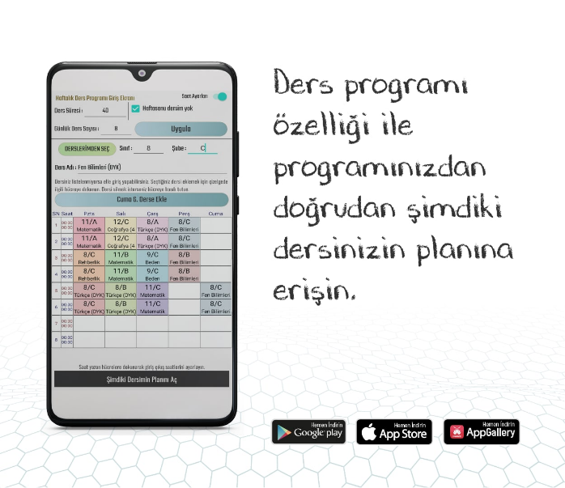 | 