2022-2023 EĞİTİM ÖĞRETİM YILI ............... ORTAOKULU 7. SINIFLAR SEÇMELİ İNGİLİZCE DERSİ ÜNİTELENDİRİLMİŞ YILLIK DERS PLANI
MONTH | DAYS | HOURS | THEME | Functions and Useful Language | Language Skills and Learning Outcomes | Materials | Evaluation
SEPTEMBER | 12-16 | 2 | 1- Appearance and Personality | Describing characters/people  Giving explanations/reasons  Making simple comparisons  Making simple inquiries  https://www.ingilizceciyiz.com/ | • Students will be able to understand clear, standard speech on appearances and personalities.  • Students will be able to talk about other people’s appearances and personalities.  • Students will be able to report on appearances and personalities of other people.  • Students will be able to understand a simple text about appearances, personalities, and comparisons including explanations and reasons.  • Students will be able to write simple pieces to compare people. | Student’s book  Interactive board  Teacher’s resources  Worksheet  Educational CD  Hand-made puppets  Real objects  Posters  Visual aids
 | 19-23 | 2
 | 26-30 | 2
 | 03 Oct – 07 Oct | 2
OCTOBER | 10-14 | 2 | 2- Sports | Talking about routines and daily  activities  Describing what people do regularly  Giving explanations and reasons | • Students will be able to recognize frequency adverbs in simple texts.  • Students will be able to ask questions related to the frequency of events.  • Students will be able to talk about routines/daily activities by using frequency adverbs and giving explanations and reasons.  • Students will be able to understand short and simple texts on sports.  • Students will be able to write pieces about routines/daily activities by using frequency adverbs. | Student’s book  Interactive board  Teacher’s resources  Worksheet  Educational CD  Hand-made puppets  Real objects  Posters  Visual aids
 | 17-21 | 2
 | 24-28 | 2
2022-2023 EĞİTİM ÖĞRETİM YILI ............... ORTAOKULU 7. SINIFLAR SEÇMELİ İNGİLİZCE DERSİ ÜNİTELENDİRİLMİŞ YILLIK DERS PLANI
MONTH | DAYS | HOURS | THEME | Functions and Useful Language | Language Skills and Learning Outcomes | Materials | Evaluation
OCTOBER | 31-04 November | 2 | 3- Biographies | Talking about past events  Making simple inquiries  Telling the time, days and dates | • Students will be able to recognize  specific information in texts dealing with past  events and dates.  • Students will be able to talk about past  events with definite time.  • Students will be able to describe past  events and experiences.  • Students will be able to spot specific  information about names and dates in past  events in written texts.  • Students will be able to write a short  and simple report about past events. | Student’s book  Interactive board  Teacher’s resources  Worksheet  Educational CD  Hand-made puppets  Real objects  Posters  Visual aids | 1ST WRITTEN EXAM
NOVEMBER | 07-11 | 2
 | 14-18 NOVEMBER MID-TERM HOLIDAY
 | 21-25 | 2 | 4- Wild Animals | Describing the frequency of actions  Making simple suggestions  Talking about past events  Giving explanations/reasons  https://www.ingilizceciyiz.com/ | • Students will be able to identify the names of wild animals in simple oral texts.  • Students will be able to ask people questions about characteristics of wild animals.  • Students will be able to make simple suggestions.  • Students will be able to report on past and present events.  • Students will be able to understand  past and present events in simple texts including explanations and reasons.  • Students will be able to spot the names of wild animals in simple texts.  • Students will be able to write pieces describing wildlife. | Student’s book  Student’s workbook  Interactive board  Teacher’s resources  Worksheet  Educational CD  Hand-made puppets  Real objects  Posters  Visual aids
DECEMBER | 28-02 DEC | 2
 | 05-09 | 2
 | 12-16 | 2
2022-2023 EĞİTİM ÖĞRETİM YILI ............... ORTAOKULU 7. SINIFLAR SEÇMELİ İNGİLİZCE DERSİ ÜNİTELENDİRİLMİŞ YILLIK DERS PLANI
MONTH | DAYS | HOURS | THEME | Functions and Useful Language | Language Skills and Learning Outcomes | Materials | Evaluation
DECEMBER | 19-23 | 2 | 5- Television | Describing what people do regularly  Expressing preferences  Stating personal opinions  Talking about past events | • Students will be able to understand simple oral texts about daily routines and preferences.  • Students will be able to ask questions about preferences of other people.  • Students will be able to talk about past events and personal experiences.  • Students will be able to state their preferences.  • Students will be able to describe past events in a simple way.  • Students will be able to understand simple texts about daily routines and preferences.  • Students will be able to understand simple texts about past events.  • Students will be able to write pieces about daily routines and preferences. | Student’s book  Interactive board  Teacher’s resources  Worksheet  Educational CD  Hand-made puppets  Real objects  Posters  Visual aids | 2ND WRITTEN EXAM
 | 26-30 | 2
JANUARY | 02-06 | 2
 | 09-13 | 2
 | 16-20 | 2 | 6- Celebrations  23 JAN  03 FEB SEMESTER HOLIDAY | Making simple suggestions  Accepting and refusing  Making arrangements and sequencing the actions  Expressing needs and quantity | • Students will be able to recognize utterances related to suggestions, needs and  quantity of things.  • Students will be able to talk about arrangements and sequences of actions.  • Students will be able to make suggestions.  • Students will be able to express needs and quantity.  • Students will be able to understand texts about celebrations.  • Students will be able to write invitation cards. | Student’s book  Interactive board  Teacher’s resources  Worksheet  Educational CD  Hand-made puppets  Real objects  Posters  Visual aids
23 JAN
03 FEB SEMESTER HOLIDAY
FEBRUARY | 06-10 | 2
 | 13-17 | 2
2022-2023 EĞİTİM ÖĞRETİM YILI ............... ORTAOKULU 7. SINIFLAR SEÇMELİ İNGİLİZCE DERSİ ÜNİTELENDİRİLMİŞ YILLIK DERS PLANI
MONTH | DAYS | HOURS | THEME | Functions and Useful Language | Language Skills and Learning Outcomes | Materials | Evaluation
FEBRUARY | 20-24 | 2 | 7- Dreams | Making predictions | • Students will be able to understand utterances about predictions and future events in simple texts.  • Students will be able to talk about simple predictions.  • Students will be able to report on simple predictions.  • Students will be able to understand short and simple texts about predictions.  • Students will be able to write pieces about predictions and future events. | Student’s book  Interactive board  Teacher’s resources  Worksheet  Educational CD  Hand-made puppets  Real objects  Posters  Visual aids
MARCH | 27-03 | 2
 | 06-10 | 2
 | 13-17 | 2 | 8- Public Buildings | Giving explanations/reasons | • Students will be able to recognize the names of the public buildings.  • Students will be able to understand explanations with reasons.  • Students will be able to give explanations with reasons.  • Students will be able to report on explanations with reasons.  • Students will be able to write pieces about explanations with reasons. | Student’s book  Interactive board  Teacher’s resources  Worksheet  Educational CD  Hand-made puppets  Real objects  Posters  Visual aids | 1ST WRITTEN EXAM
 | 20-24 | 2
 | 27-31 | 2
APRIL | 03-07 | 2
 | 10-14 | 2
17-20 APRIL
MID-TERM HOLIDAY
2022-2023 EĞİTİM ÖĞRETİM YILI ............... ORTAOKULU 7. SINIFLAR SEÇMELİ İNGİLİZCE DERSİ ÜNİTELENDİRİLMİŞ YILLIK DERS PLANI
MONTH | DAYS | HOURS | THEME | Functions and Useful Language | Language Skills and Learning Outcomes | Materials | Evaluation
APRIL | 24-28 | 2 | 9- Environment | Describing simple processes  Expressing obligation  Giving explanations/reasons  https://www.ingilizceciyiz.com/ | • Students will be able to understand phrases and the highest frequency vocabulary about environment.  • Students will be able to follow how a simple process is described in clear texts.  • Students will be able to talk about obligations.  • Students will be able to give simple instructions for a specific process.  • Students will be able to give a simple description or presentation of a process.  • Students will be able to identify specific information in various texts about environment.  • Students will be able to write short, simple messages about environment.  • Students will be able to write short description of a process. | Student’s book  Interactive board  Teacher’s resources  Worksheet  Educational CD  Hand-made puppets  Real objects  Posters  Visual aids
MAY | 01-05 | 2
 | 08-12 | 2
 | 15-19 | 2
 | 22-26 | 2 | 10- Planets | Making simple comparisons  Talking about past events  Making simple inquiries | • Students will be able to make simple comparisons.  • Students will be able to talk about past events.  • Students will be able to report on general truths in various ways.  • Students will be able to identify specific information in various texts about facts and general truths.  • Students will be able to identify specific information about past events.  • Students will be able to write short and basic descriptions of facts and general truths. | Student’s book  Interactive board  Teacher’s resources  Worksheet  Educational CD  Hand-made puppets  Real objects  Posters  Visual aids | 2ND WRITTEN EXAM
 | 29-02 | 2
JUNE | 05-09 | 2
 | 12-16 | 2
https://www.ingilizceciyiz.com/
UYGUNDUR
Okan GÜLTEKİN 09/09/2022
İngilizce Öğretmeni Sadece sosyal medyada yayınladığımız ücretsiz İngilizce Öğretmenlerine Özel Yazılı Soruları
ve ihtiyacınız olan tüm evraklar için sosyal medya hesaplarımızdan bizi takip ediniz! OKUL MÜDÜRÜ
https://www.facebook.com/groups/ingilizceciyiz https://www.instagram.com/ingilizceciyiz_com/ https://twitter.com/ingilizceciyiz1

Bu planı cep telefonunuzda kullanmak için aşağıdaki bağlantılardan mobil uygulamamızı indirin. Ücretsiz! (Bağlantı için Ctrl + Tıkla)

Bu plan ingilizceciyiz.com sitesinin izni ile osmankarakaya.net sitesinde paylaşılmaktadır.
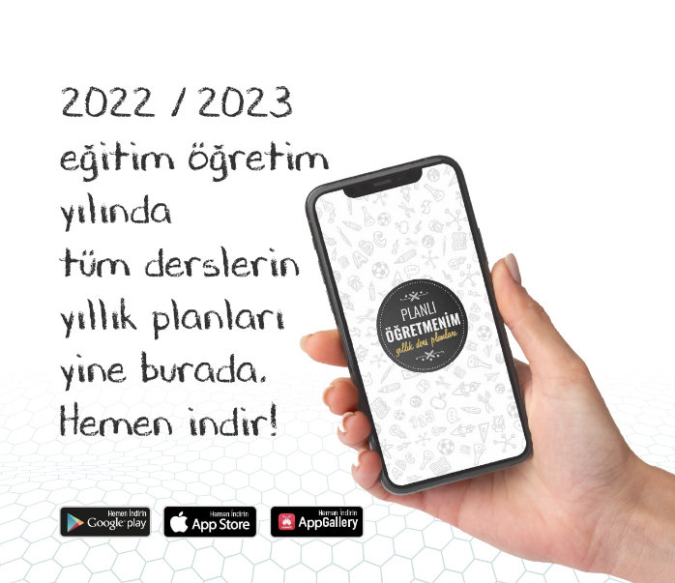 | 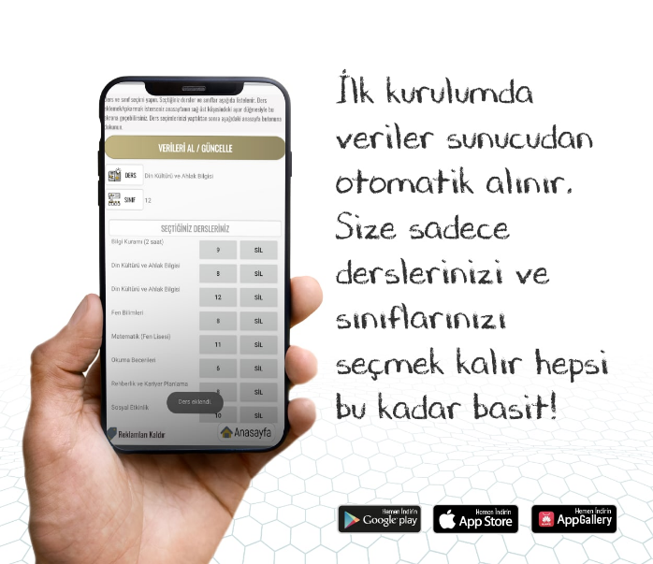 | 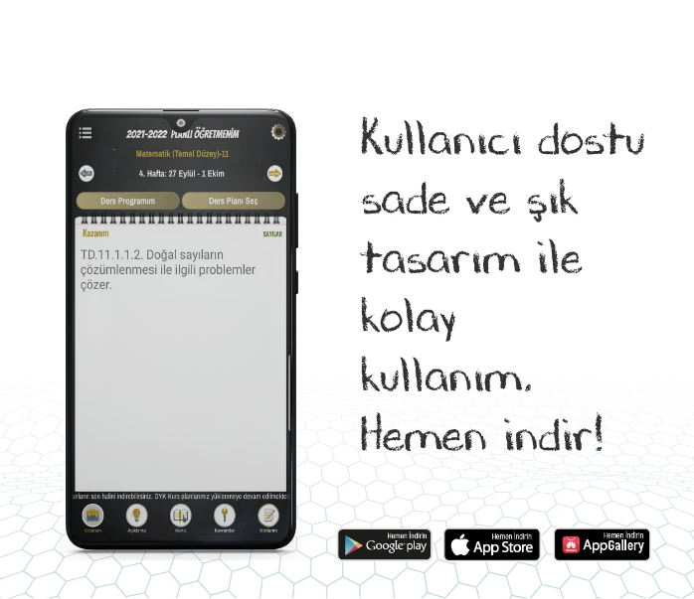
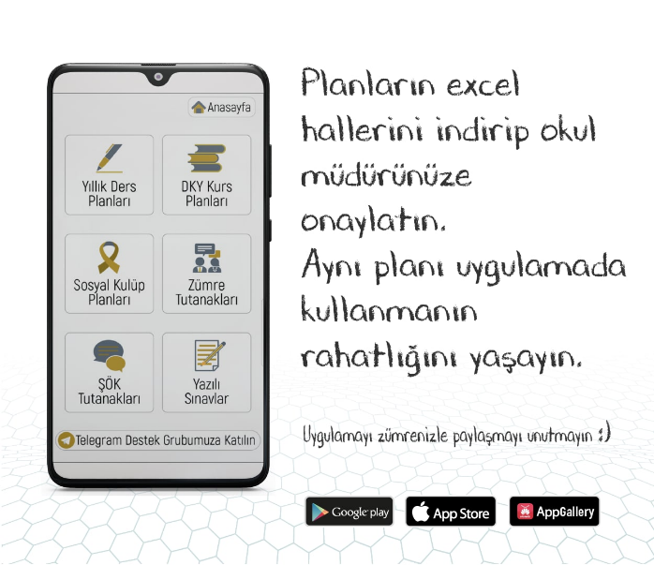 | 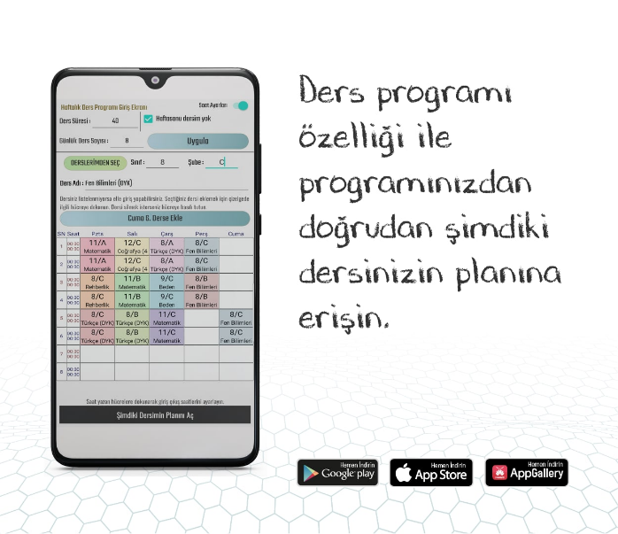 | 