2022-2023 EĞİTİM ÖĞRETİM YILI ............... ORTAOKULU 8. SINIFLAR SEÇMELİ İNGİLİZCE DERSİ ÜNİTELENDİRİLMİŞ YILLIK DERS PLANI
MONTH | DAYS | HOURS | THEME | Functions and Useful Language | Language Skills and Learning Outcomes | Materials | Evaluation
SEPTEMBER | 12-16 | 2 | 1- Friendship | Acepting and refusing / Apologizing  Giving explanations and reasons  Making simple inquiries  https://www.ingilizceciyiz.com/ | • Students will be able to interact with reasonable ease in structured situations and short conversations involving accepting and refusing an offer/invitation, apologizing and making simple inquiries.  • Students will be able to structure a talk to make simple inquiries, give explanations and  reasons.  • Students will be able to understand short and simple invitation letters, cards and e-mails.  • Students will be able to write a short and simple letter apologizing and giving reasons for not attending a party in response to an invitation. | Student’s book  Interactive board  Teacher’s resources  Worksheet  Educational CD  Hand-made puppets  Real objects  Posters  Visual aids
 | 19-23 | 2
 | 26-30 | 2
 | 03 Oct – 07 Oct | 2
OCTOBER | 10-14 | 2 | 2- Teen Life | Expressing likes and dislikes  Expressing preferences  Stating personal opinions  (Making simple inquiries) | • Students will be able to understand phrases and expressions about regular activities of teenagers.  • Students will be able to talk about regular activities of teenagers.  • Students will be able to express what they prefer, like and dislike.  • Students will be able to understand short and simple texts about regular activities of teenagers.  • Students will be able to write a short  and simple paragraph about regular activities of teenagers. | Student’s book  Interactive board  Teacher’s resources  Worksheet  Educational CD  Hand-made puppets  Real objects  Posters  Visual aids
 | 17-21 | 2
 | 24-28 | 2
2022-2023 EĞİTİM ÖĞRETİM YILI ............... ORTAOKULU 8. SINIFLAR SEÇMELİ İNGİLİZCE DERSİ ÜNİTELENDİRİLMİŞ YILLIK DERS PLANI
MONTH | DAYS | HOURS | THEME | Functions and Useful Language | Language Skills and Learning Outcomes | Materials | Evaluation
OCTOBER | 31-04 November | 2 | 3- In the Kitchen | Describing simple processes  Expressing preferences  Making simple inquiries | • Students will be able to get the gist of short, clear, simple descriptions of a process.  • Students will be able to give a simple description about a process.  • Students will be able to understand the overall meaning of short texts about a process.  • Students will be able to guess the meaning of unknown words from the text.  • Students will be able to write a series of simple phrases and sentences by using linkers to describe a process. | Student’s book  Interactive board  Teacher’s resources  Worksheet  Educational CD  Hand-made puppets  Real objects  Posters  Visual aids | 1ST WRITTEN EXAM
NOVEMBER | 07-11 | 2
 | 14-18 NOVEMBER MID-TERM HOLIDAY
 | 21-25 | 2 | 4- On the Phone | Following phone conversations  Stating decisions taken at the time of speaking  https://www.ingilizceciyiz.com/ | • Students will be able to follow a phone conversation.  • Students will be able to make a simple phone call asking and responding to questions.  • Students will be able to express their decisions taken at the moment of conversation.  • Students will be able to understand short and simple texts with related vocabulary.  • Students will be able to write short and  simple conversations. | Student’s book  Student’s workbook  Interactive board  Teacher’s resources  Worksheet  Educational CD  Hand-made puppets  Real objects  Posters  Visual aids
DECEMBER | 28-02 DEC | 2
 | 05-09 | 2
 | 12-16 | 2
2022-2023 EĞİTİM ÖĞRETİM YILI ............... ORTAOKULU 8. SINIFLAR SEÇMELİ İNGİLİZCE DERSİ ÜNİTELENDİRİLMİŞ YILLIK DERS PLANI
MONTH | DAYS | HOURS | THEME | Functions and Useful Language | Language Skills and Learning Outcomes | Materials | Evaluation
DECEMBER | 19-23 | 2 | 5- The Internet | Accepting and refusing  Making excuses | • Students will be able to talk about their Internet habits.  • Students will be able to exchange information about the Internet.  • Students will be able to make excuses, and to accept and refuse offers by using a series of phrases and simple sentences.  • Students will be able to identify main ideas in short and simple texts about internet habits.  • Students will be able to find specific information about the Internet in various texts.  • Students will be able to write a basic paragraph to describe their internet habits. | Student’s book  Interactive board  Teacher’s resources  Worksheet  Educational CD  Hand-made puppets  Real objects  Posters  Visual aids | 2ND WRITTEN EXAM
 | 26-30 | 2
JANUARY | 02-06 | 2
 | 09-13 | 2
 | 16-20 | 2 | 6- Adventures | Expressing preferences  Giving explanations and reasons  Making comparisons | • Students will be able to talk about comparisons, preferences and their reasons.  • Students will be able to make comparisons about sports and games by using simple descriptive language.  • Students will be able to understand short and simple texts to find the main points about adventures.  • Students will be able to write a short and simple paragraph comparing two objects. | Student’s book  Interactive board  Teacher’s resources  Worksheet  Educational CD  Hand-made puppets  Real objects  Posters  Visual aids
23 JAN
03 FEB SEMESTER HOLIDAY
FEBRUARY | 06-10 | 2
 | 13-17 | 2
2022-2023 EĞİTİM ÖĞRETİM YILI ............... ORTAOKULU 8. SINIFLAR SEÇMELİ İNGİLİZCE DERSİ ÜNİTELENDİRİLMİŞ YILLIK DERS PLANI
MONTH | DAYS | HOURS | THEME | Functions and Useful Language | Language Skills and Learning Outcomes | Materials | Evaluation
FEBRUARY | 20-24 | 2 | 7- Tourism | Describing places  Expressing preferences  Giving explanations/reasons  Making comparisons  Talking about experiences | • Students will be able to exchange information about tourism.  • Students will be able to talk about their favorite tourist attractions by giving details.  • Students will be able to express their preferences for particular tourist attractions and give reasons.  • Students will be able to make simple comparisons between different tourist attractions.  • Students will be able to express their experiences about places.  • Students will be able to design a brochure, advertisement or a postcard about their favorite tourist attraction(s).  • Students will be able to find specific information from various texts about tourism. | Student’s book  Interactive board  Teacher’s resources  Worksheet  Educational CD  Hand-made puppets  Real objects  Posters  Visual aids
MARCH | 27-03 | 2
 | 06-10 | 2
 | 13-17 | 2 | 8- Chores | Expressing likes and dislikes  Expressing obligation  Expressing responsibilities | • Students will be able to understand obligations, likes and dislikes.  • Students will be able to talk about responsibilities.  • Students will be able to express their obligations, likes and dislikes in simple terms.  • Students will be able to understand various short and simple texts about responsibilities.  • Students will be able to write short and simple poems/stories about their feelings and responsibilities. | Student’s book  Interactive board  Teacher’s resources  Worksheet  Educational CD  Hand-made puppets  Real objects  Posters  Visual aids | 1ST WRITTEN EXAM
 | 20-24 | 2
 | 27-31 | 2
APRIL | 03-07 | 2
 | 10-14 | 2
17-20 APRIL
MID-TERM HOLIDAY
2022-2023 EĞİTİM ÖĞRETİM YILI ............... ORTAOKULU 8. SINIFLAR SEÇMELİ İNGİLİZCE DERSİ ÜNİTELENDİRİLMİŞ YILLIK DERS PLANI
MONTH | DAYS | HOURS | THEME | Functions and Useful Language | Language Skills and Learning Outcomes | Materials | Evaluation
APRIL | 24-28 | 2 | 9- Science | Describing the actions happening currently  Talking about past events  https://www.ingilizceciyiz.com/ | • Students will be able to talk about actions happening currently and in the past.  • Students will be able to involve in simple discussions about scientific achievements.  • Students will be able to describe actions happening currently.  • Students will be able to identify main ideas and supporting details in short texts about science.  • Students will be able to present information about scientific achievements in a simple way.  • Students will be able to write simple descriptions of scientific achievements in a short paragraph. | Student’s book  Interactive board  Teacher’s resources  Worksheet  Educational CD  Hand-made puppets  Real objects  Posters  Visual aids
 | 01-05 | 2
MAY | 08-12 | 2
 | 15-19 | 2
 | 22-26 | 2
 | 29-02 | 2 | 10- Nature | Making predictions about the future  (Giving reasons and results) | • Students will be able to talk about predictions concerning future of the Earth.  • Students will be able to negotiate reasons and results to support their predictions about natural forces and disasters.  • Students will be able to express predictions concerning future of the Earth.  • Students will be able to give reasons and results to support their predictions about natural forces and disasters.  • Students will be able to identify specific information in simple texts about natural forces and disasters.  • Students will be able to write a short and simple paragraph about reasons and results of natural forces and disasters. | Student’s book  Interactive board  Teacher’s resources  Worksheet  Educational CD  Hand-made puppets  Real objects  Posters  Visual aids | 2ND WRITTEN EXAM
JUNE | 05-09 | 2
 | 12-16 | 2
https://www.ingilizceciyiz.com/
UYGUNDUR
Okan GÜLTEKİN 09/09/2022
İngilizce Öğretmeni Sadece sosyal medyada yayınladığımız ücretsiz İngilizce Öğretmenlerine Özel Yazılı Soruları
ve ihtiyacınız olan tüm evraklar için sosyal medya hesaplarımızdan bizi takip ediniz! OKUL MÜDÜRÜ
https://www.facebook.com/groups/ingilizceciyiz https://www.instagram.com/ingilizceciyiz_com/ https://twitter.com/ingilizceciyiz1

Bu planı cep telefonunuzda kullanmak için aşağıdaki bağlantılardan mobil uygulamamızı indirin. Ücretsiz! (Bağlantı için Ctrl + Tıkla)

Bu plan ingilizceciyiz.com sitesinin izni ile osmankarakaya.net sitesinde paylaşılmaktadır.
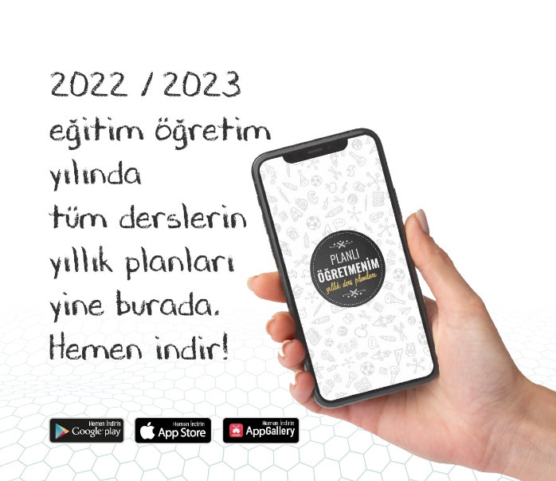 | 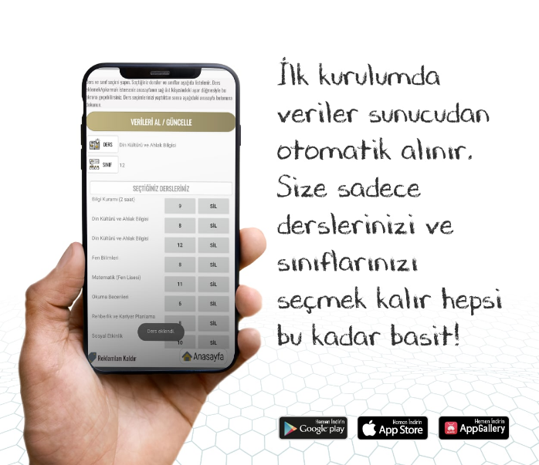 | 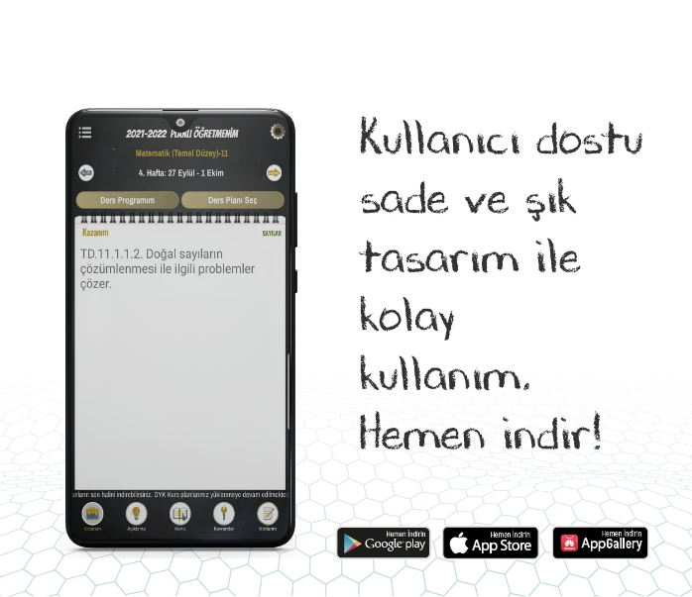
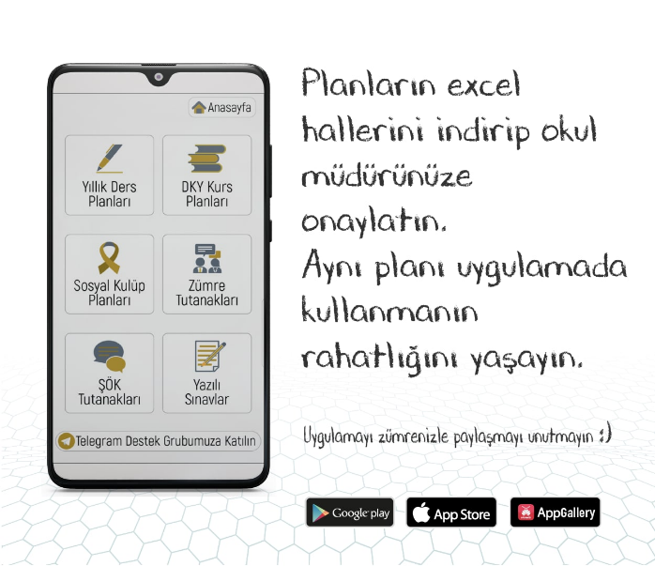 | 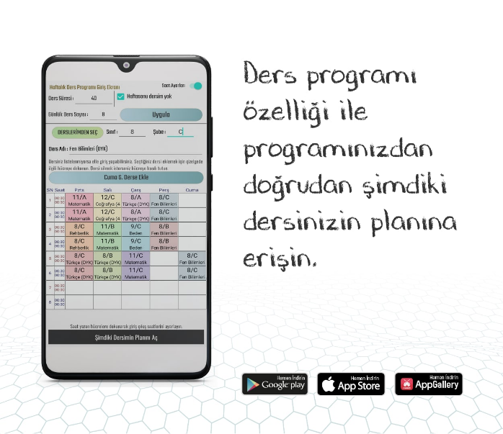 | 